**New Patient Pack**

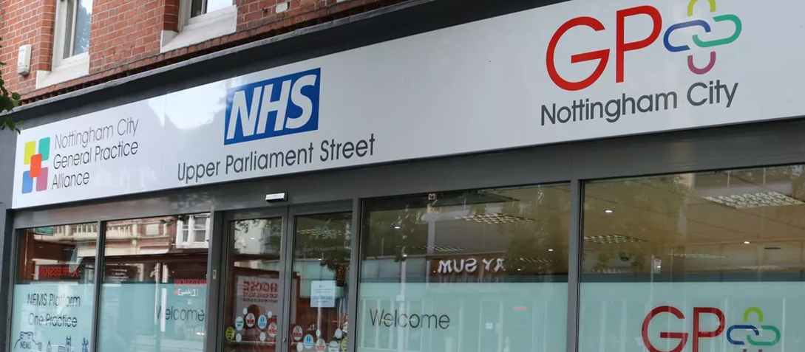

# **Opening Times**

**Monday - Friday:** 8.00am—6:30pm

**Saturday – Sunday:** CLOSED

**Closed Bank Holidays**

# **Content**

* Useful Information
* Services
* Registration
* Appointments
* Telephone appointments
* Out of hours appointments
* Online services
* Prescriptions process and e-prescriptions
* Home visits
* Disability access
* Patient Participation Group (PPG)
* Compliments and complaints
* When the surgery is closed
* Patient’s responsibilities
* Zero tolerance

# **Useful information**

Parliament Street Medical Centre is managed and operated by Nottingham City GP Alliance (NCGPA) who are a federation owned by 36 local GP practices in Nottingham city.

# **NCGPA registered office address:**

* **Address:** *79a Upper Parliament Street, Nottingham, NG1 6LD*
* **Tel:** 0115 883 1900
* **Website:** [www.ncgpa.org.uk](http://www.ncgpa.org.uk/)

# **Parliament Street Medical Centre address:**

* **Address:** *Parliament Street Medical Centre, 79a Upper Parliament Street, Nottingham, NG1 6LD*
* **Tel:** 0115 883 1900
* **Website:** [www.greendaleprimarycarecentre.co.uk](http://www.greendaleprimarycarecentre.co.uk/)

# **Patient responsibility**

* Inform the practice if any contact information has changed (e.g. address, telephone number, next of kin).
* Attend practice on time for appointments - patients who arrive more than five minutes late will not be seen.
* Cancel appointments at least two hours before so that the appointment can be offered to another patient.
* Treat all staff with respect – any kind of verbal or physical abuse will not be tolerated.

# **Zero-tolerance**

We do not tolerate abuse of any kind towards our staff. If you are abusive towards any member of our staff, we have the right to remove you from the patient list and added to the zero-tolerance clinic. This means you will only be able to attend designated zero-tolerance clinics for GP care.

**Services provided:**

* Dietary advice
* Employment insurance medicals (private work with a charge)
* Joint injections
* Weight management
* New patient and well person checks
* Long-term condition reviews (e.g. asthma, COPD, and diabetes)
* Family planning and contraception services
* C-Card scheme
* Heart disease risk assessment
* Travel advice and immunisations
* Cervical screening
* Dressings and wound care
* Phlebotomy (blood tests)
* Pharmacist medication reviews

# **Registration**

To register at the practice, you need to pick up a registration form from reception. Forms can also be downloaded from the website, but you **MUST** attend the practice to register. You will be asked to show proof of address and your passport so we can ensure we have all your correct details.

If you are not a British citizen, we will need to check your visa status in your passport to check eligibility for NHS services. If possible, please bring your vaccination record when you come to register.

# **Appointments**

We offer a range of pre-bookable appointments:

* Appointments with a nurse or a healthcare assistant for routine blood tests and long-term condition reviews such as diabetes, COPD, and asthma are available to pre-book up to four weeks ahead.
* Appointments with a GP are available to pre-book up to four weeks in advance.
* Appointments are released at 8.00am for urgent on the day appointments.

To ensure that you are booked with the appropriate clinician, our reception team will ask why you need to make an appointment.

Patients requesting appointments for minor illnesses may be directed to self-care, or signposted to a pharmacy for advice and over-the-counter treatments. Please be advised, if there’s an emergency that your GP needs to attend, they may be late to your appointment.

# **Telephone appointments with doctors**

If you’ve got a medical issue that doesn’t need a face-to-face appointment you can book to speak to a doctor over the phone. These calls can be booked in the morning before 10am.

We are unable to give you an exact time when you will receive your call back, but it will be any time from making the appointment to closure of the surgery at 6.30pm, depending on the doctor’s availability.

Please be available to take the call from the doctor as they are not able to keep trying to call you. If you don’t answer the appointment will be cancelled.

It is important to keep your contact information and address up to date. When you call the surgery for a telephone appointment, you will need to leave your preferred form of contact (mobile or home phone) to ensure we can get through to you.

When the doctor rings you, it will show up as a private number.

# **Out of hours appointments**

For patients who find it more convenient to have an appointment at the weekend or later in the day, we can book appointments with GP+.

Information about GP+ appointments can be found online or at the practice. The reception team can also provide you with more information on the service.

GP+ is not a walk-in service. Appointments must be booked via our reception team.

**GP+ Nottingham opening hours:**

* **Monday - Friday:** 4PM - 8PM
* **Saturday:** 9AM - 5PM
* **Sunday and Bank Holidays:** Closed

**Location:**

* *GP+ Nottingham City,*
* *79a Upper Parliament Street*
* *Nottingham*
* *NG1 6LD*

# **Online services**

We recommend that our patients sign up for the online services. This is simple to do on your mobile phone, tablet, laptop, or desktop computer.

Online services enable you to order your prescription for repeat medication, request access to test results, and book some appointments from the comfort of your own home.

We use [SystmOnline](https://systmonline.tpp-uk.com/2/Login?Date=20231206105706) for online patient booking services. To register to use our online services speak to a member of reception and make sure you have got a photographic ID (passport/driving licence) and a recent proof of your address with you.

You will also be registered for the new [NHS App](https://www.nhs.uk/nhs-app/about-the-nhs-app/). On the app you will be to view, amend, and order prescriptions. There are also a limited number of appointments available to book online daily.

# **Prescriptions and e-prescriptions**

Repeat prescriptions can be requested by:

* **NHS App** - Free download from your phone’s app store
* **Online** – Visit [systmonline.tpp-uk.com](https://systmonline.tpp-uk.com/2/Login?Date=20231206105706)
* **Email** - [nnicb-nn.receptiony02847@nhs.net](mailto:ncgpa.stubit@nhs.ne)(please ensure you add your full name, date of birth, and the names of the items you are requesting to the email message).
* **Drop off your repeat in person.**
* **Post your repeat direct via the Royal Mail.**

We **do not** take prescription requests over the telephone.

Please allow 48 hours for your prescription to be ready (this excludes weekends and bank holidays).

We ask all patients to order their own medication and not to use a pharmacy for repeat prescriptions, as this often leads to unneeded prescriptions being ordered, wasting NHS time and money.

We also provide the Electronic Prescription Service (EPS) at our practice. This service allows GPs to electronically send your prescription to your chosen pharmacy.

Using this system allows the practice to track your prescription, reducing the need to re-print missing prescriptions. The system is safer and less time consuming for practice staff and patients. Please speak to your pharmacy to sign up for EPS.

If you have a prescription query, please call reception after 10.00am.

# **Home visits**

We only provide home visits for patients who have a severe disability or medical condition and have been registered with the practice as housebound.

If you need a home visit, please call reception before 10:30am and specify that you require a home visit. If you are not registered as house bound and feel you need to be visited by a doctor, you will be contacted over the phone first to decide if a visit is appropriate.

If the clinician feels you do not meet the criteria for home a visit, you will need to come into the surgery to be seen.

**What qualifies you as housebound or homebound?**

* A disability which requires full time care and assistance via a carer or family member.
* Not being able to walk a long distance.
* Mental disability that makes it difficult to go outside.

If you are a carer for somebody that qualifies under these criteria, please speak to a member of the reception team for more information.

# **Disability accessible entrances**

Our surgeries are completely disability accessible. We have automatic entrance doors that are sensor operated so you don’t need to press a button.

# **Patient Participation Group (PPG)**

We have a Patient Participation Group who meet and discuss practice matters. They meet at the practice approximately every two months and always welcome new members.

If you are interested in joining our PPG, please ask at reception for a sign-up form. If you aren’t available to attend meetings during the day you can still give your input via our ‘Practice Patient’ WhatsApp group. please let reception know if you are interested in joining this group.

The group is run by the members, not us at the practice, although representatives of the practice do attend the meetings. The PPG is a fantastic opportunity to put forward ideas to improve or develop the practice or to support the practice in new initiatives.

**Patient feedback and complaints procedure**

We make every effort to give the best service possible to everyone who attends our practice. However, we are aware things can sometimes go wrong and a patient may have cause for complaint. When this happens, we aim to resolve the issue as quickly and as amicably as possible.

If you have a concern while at the practice, please ask to speak to reception and they handle your concerns appropriately. If you wish to complain in writing, you can pick up a leaflet from reception which provides you with all the information required. Alternatively, you can email your concern or complaint to: [nnicb-nn.receptiony02847@nhs.net](mailto:nnicb-nn.c84063@nhs.net).

The practice manager will be involved if appropriate. They review all complaints to ensure the same issues are not encountered again, and where necessary new training, policies, procedures are put in place to improve our service.

Information on the complaints process is also on our website at [www.nemsplatformone.co.uk](http://www.nemsplatformone.co.uk). If you do not wish to complain directly to the practice, you can also contact the Nottingham and Nottinghamshire Integrated Care Board at [nnicb-nn.patientexperience@nhs.net](mailto:nnicb-nn.patientexperience@nhs.net).

You can also take part in our patient survey. We discuss the survey results regularly in meetings and with our PPG to assist in developing the practice further and providing more services to our patients.

You can find the surveys on the front desk. Please ask for a pen, and when you are finished pass them back to a member of the reception team.

Your feedback is appreciated, and details of comments and any changes implemented as a result can be found on our “You Said, We Did” notice board in the waiting area.